**Program Run**

The following demonstrate a full program run for Lab3. As depicted, the programs run until the user presses 3 to exit. The user can select to run automated tests or create their own custom test. For the automated tests, the user can determine which of the 10 functions they want to test for the SortedList and List.

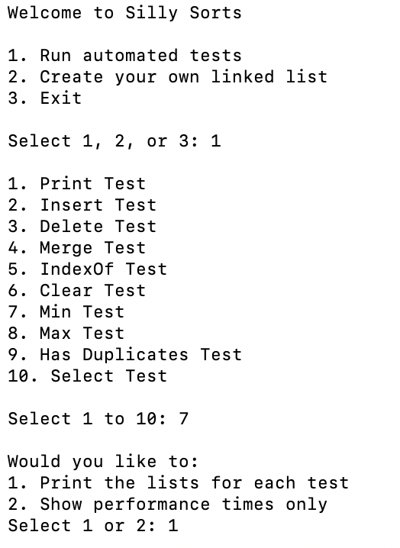

Users can decide to only print the number of comparisons and performance time for each algorithm or to also display each list after the algorithm was applied.

Example of displaying lists:

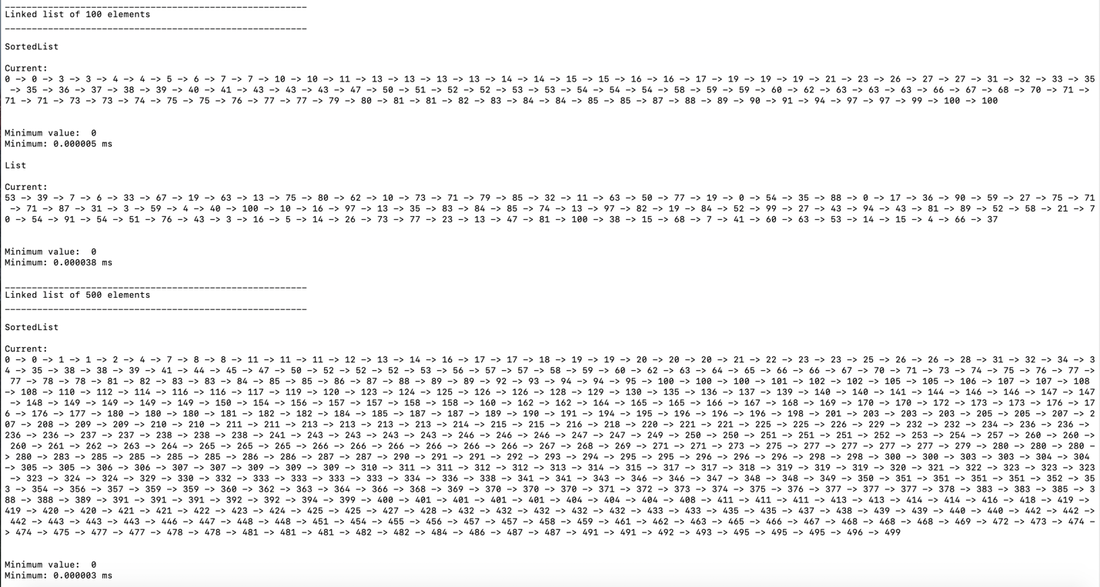

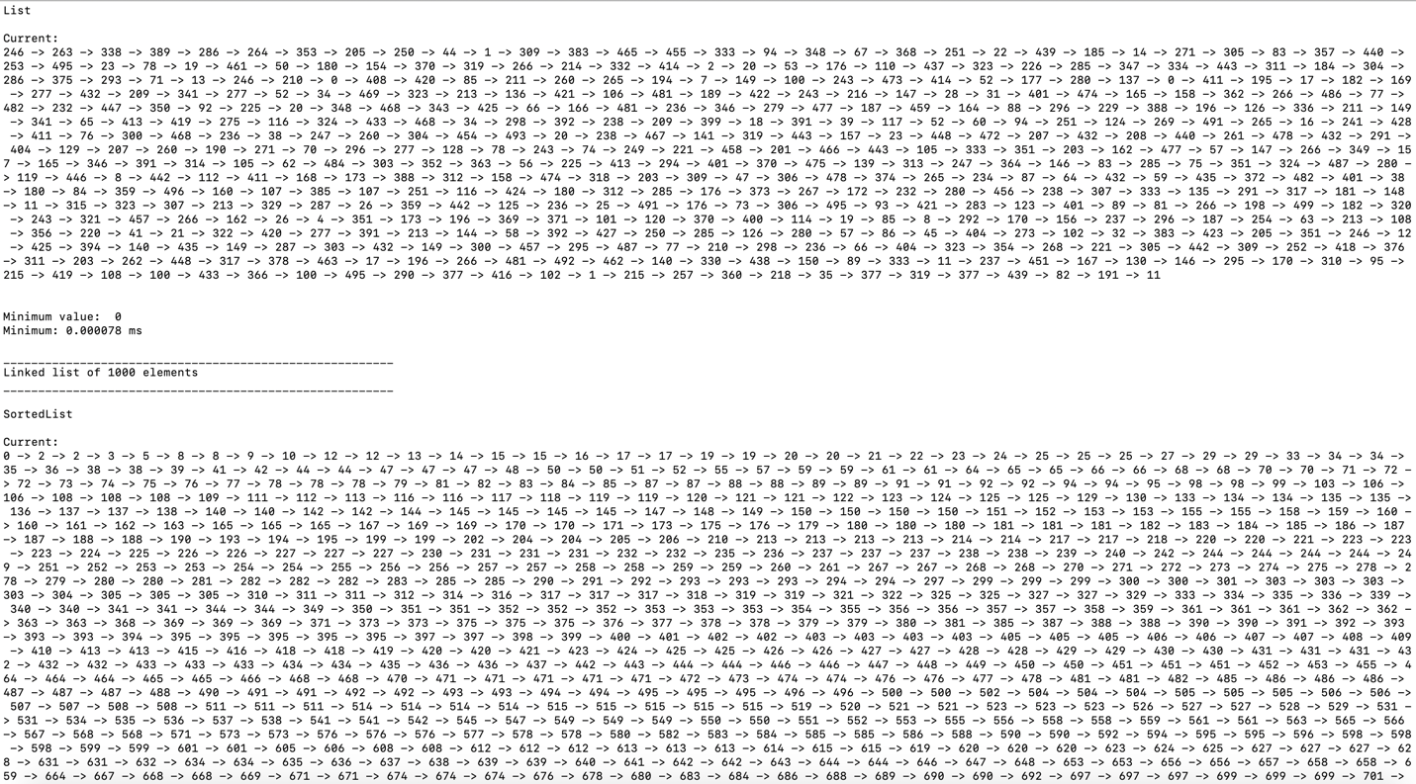

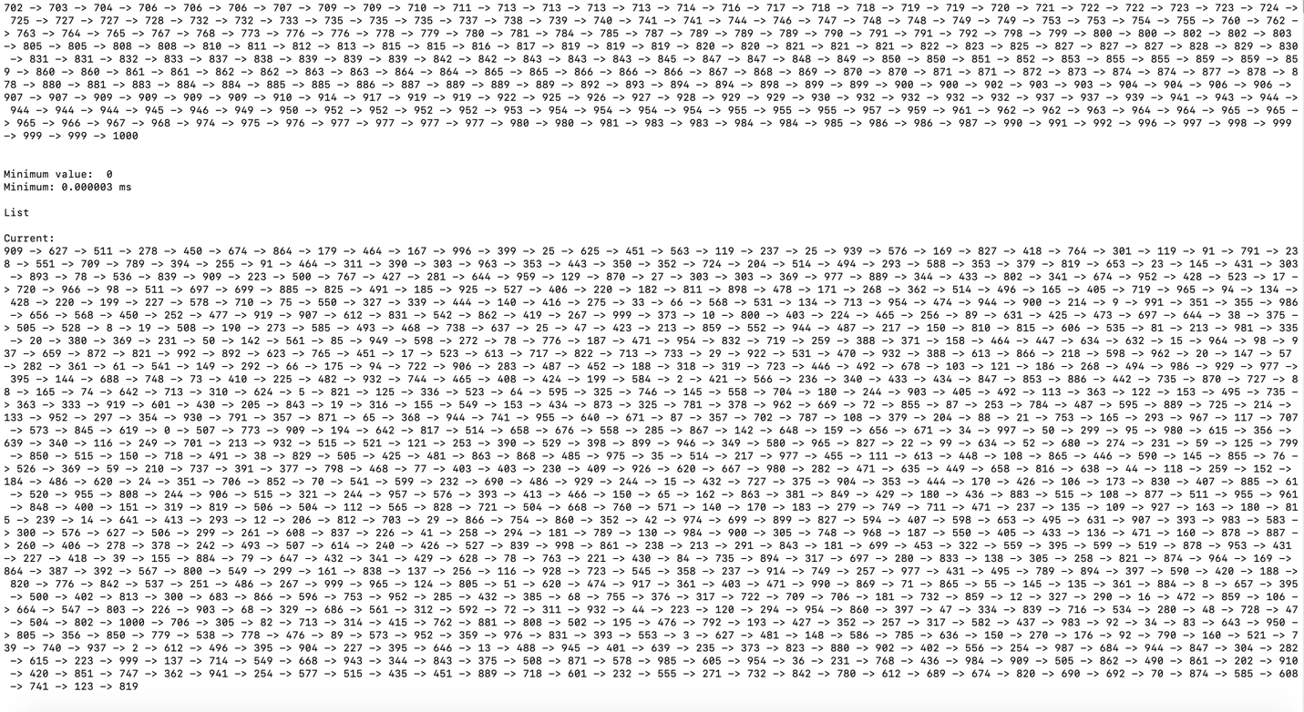

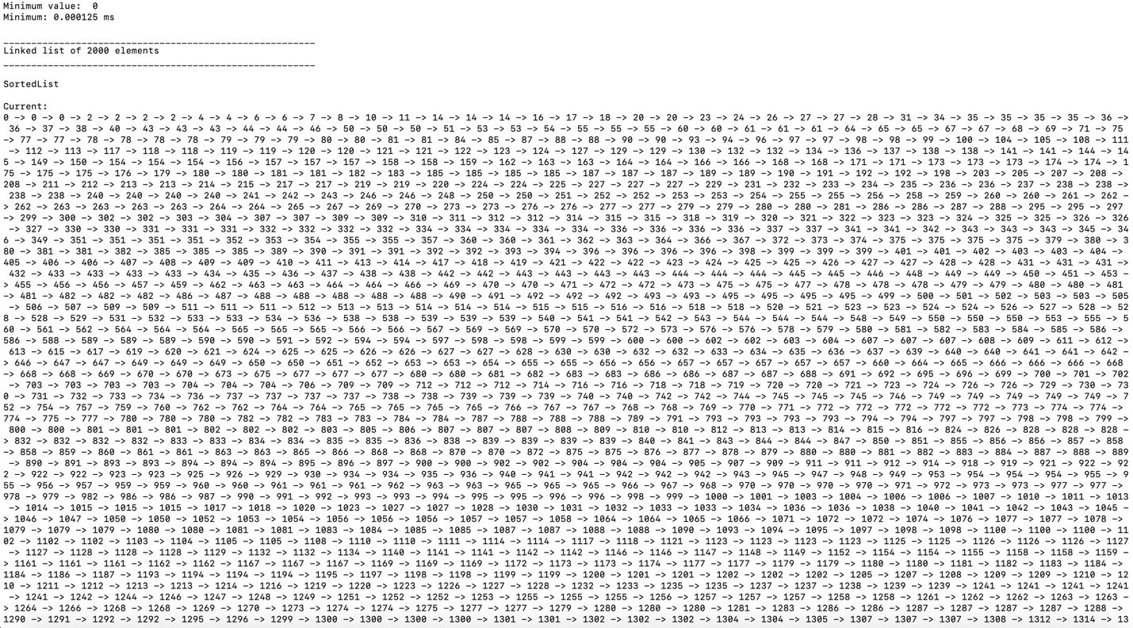

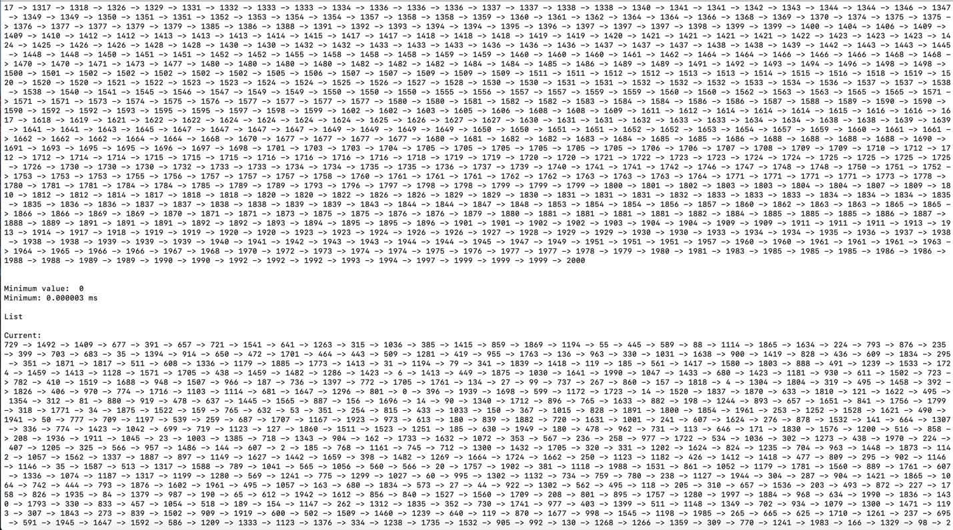

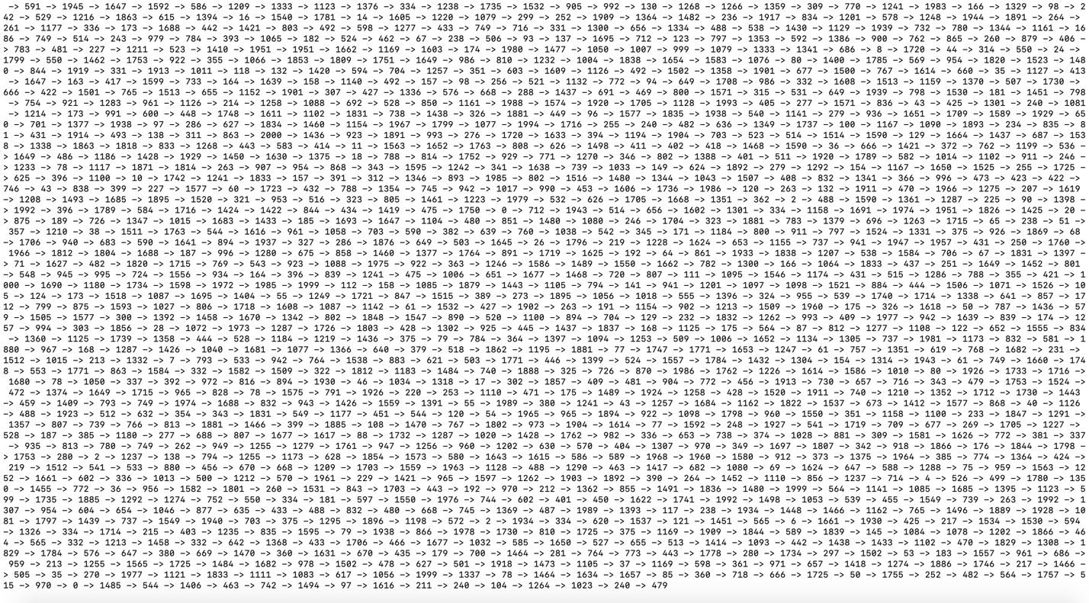

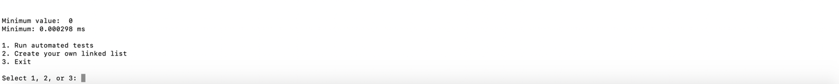

Example of only displaying the performance time and runtime complexity:

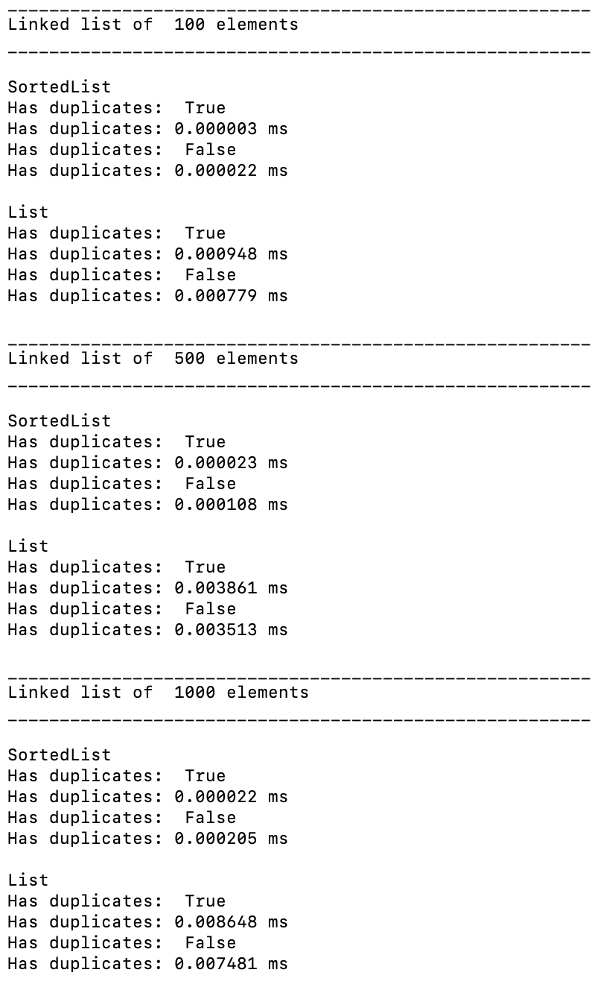

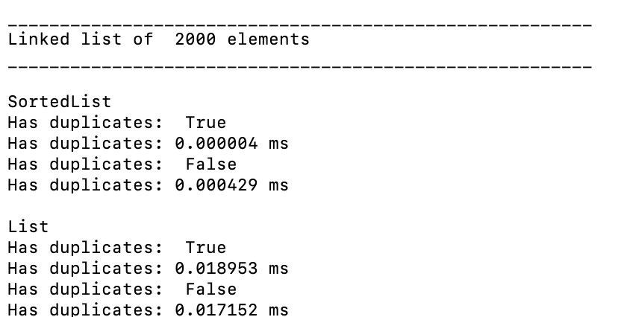

Note each automated test shows the performance time for the functions performed on Lists and SortedLists of size 100, 500, 1000, and 2000. Additionally, both the List and SortedList tested have the same elements that are randomly generated. The only difference is that the integers in the SortedList are ordered.

Example of custom test:

For the custom tests, the user can create their own SortedList and List and perform any of the functions defined.

